***THOMAS SHOPPING PLAZA***

**THE BEST BRANDS IN YOUR HANDS**

***FREE☺☺ SHIPPING***

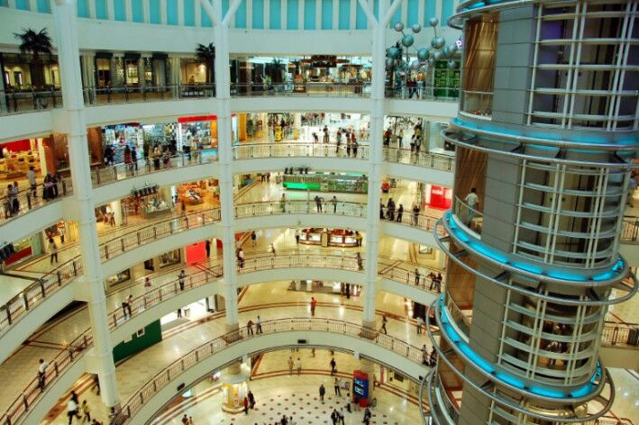

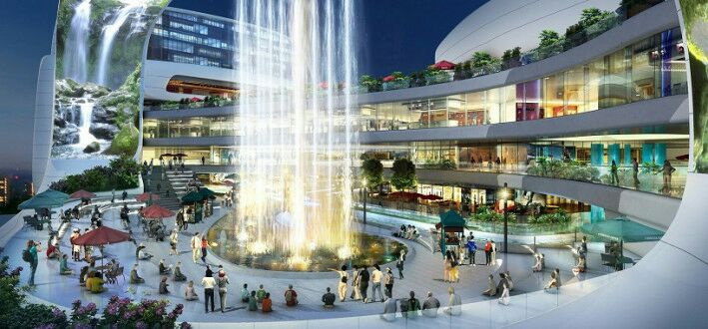

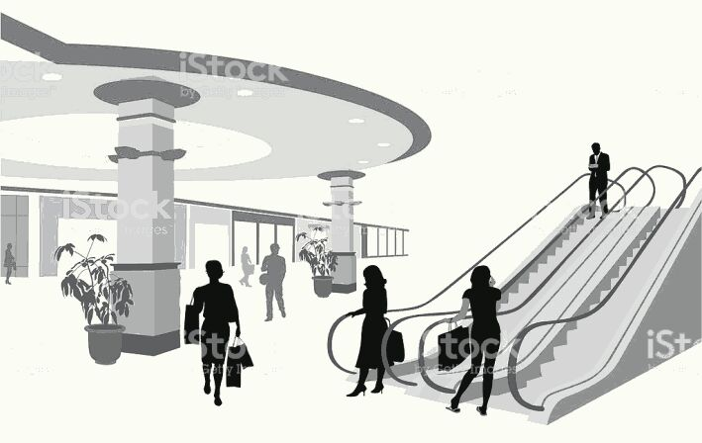

Koteshwor, Kathmandu, Nepal

01-520160, 9805982968.